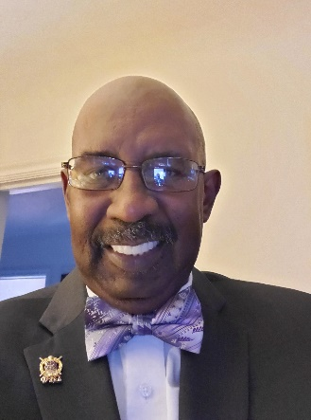
Deolis Allen Jr., MBA
Business Faculty WCCCD
Colleagues,
I am running for a position on our bargaining committee. I am writing this short statement to introduce myself to any of you who do not already know me. I am a 1991 Univ of Michigan MBA. I am anxious to do my part to serve our faculty and our institution. I believe that my experiences as a full-time faculty member, adjunct faculty member and as an administrator, dean and director of education, give me unique perspective when it comes to bargaining for faculty.
I have been a college instructor since 1990 and I began teaching at WCCCD in 2006 as an adjunct faculty. My undergraduate degree in Communication helps me to see different perspectives when negotiating. As the dean and vice president of academics at Lewis College of Business I know what is required economically to maintain a school. However, my experiences and education tell me that the school is the faculty and the students. Everything and everyone else are support. If I am selected by my peers to serve them on the bargaining team, I will do so with the perspective that the school is in fact the faculty and the students.

Specifically, concerning our contract I believe that our current contract is a good starting point. I would seek to maintain our current contract and seek to improve on specific areas like wages and working during the pandemic. Again, I was a part-time instructor for nine years and I have been full-time for six years. I strongly believe that we are all one faculty.

